Language: HCL (Hashicorp Configuration Language) || Declarative Language

File: main.tf

<block>:Resource = Object that terraform manages. (File, EC2 instance, S3, ECS, IAM users and groups).

<parameter>:Resource Type= (local/aws: Provider)_(file: Resource); Resource Name= ajinkya.

Key= value : Arguments.

Example:

<block> <parameter> {

key = value

}

=====================================================================================

resource "local_file" "ajinkya" {

filename = "/root/terraform/ajinkya.txt"

content = "Hi Ajinkya Chandekar"

}

=====================================================================================

terraform init

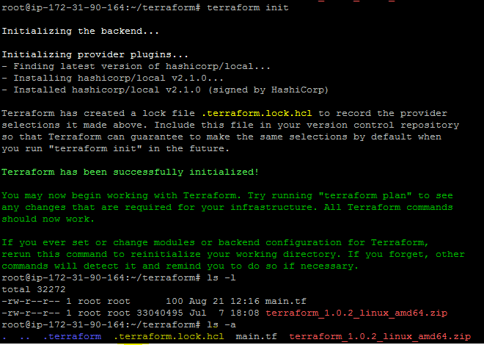

The file “.terraform.lock.hcl” records the provider selection within it.

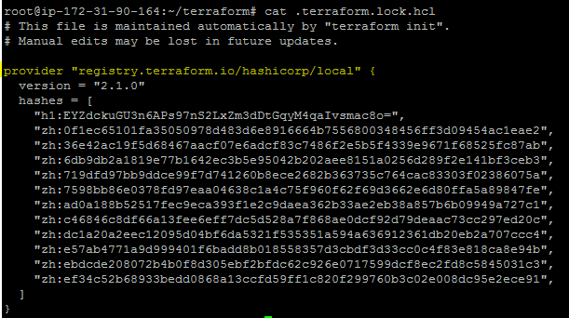

terraform validate

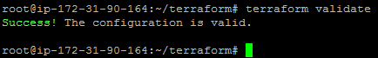

terraform plan

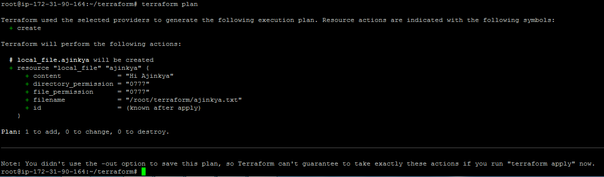

Here, + symbol means it will create the new resource with some default optional arguments that we did not specify. This will not perform any action but just for the user review.

terraform apply

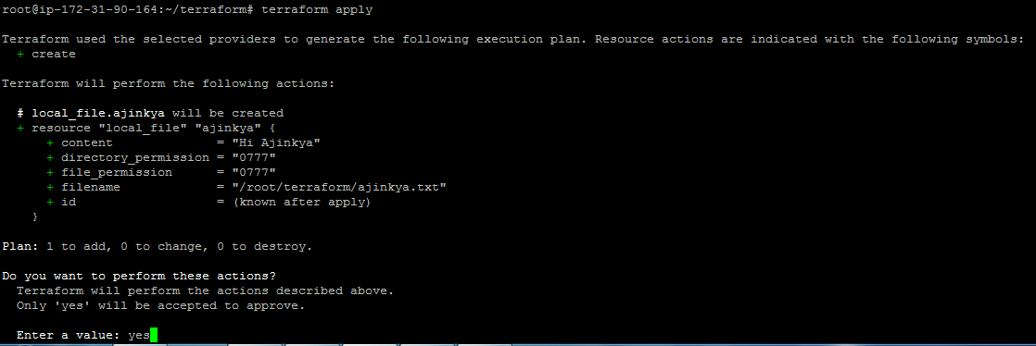

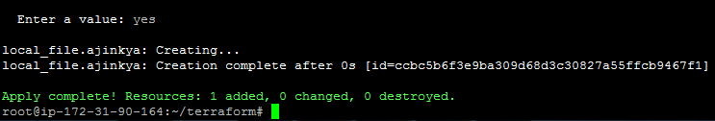

terraform show

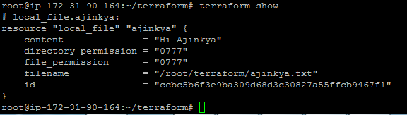

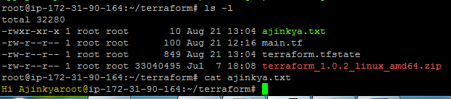

It will also create the file “terraform.tfstate”

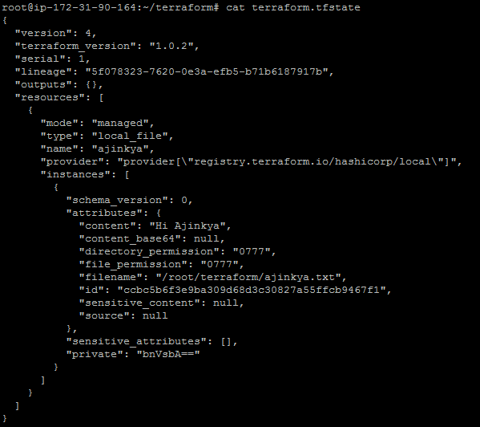

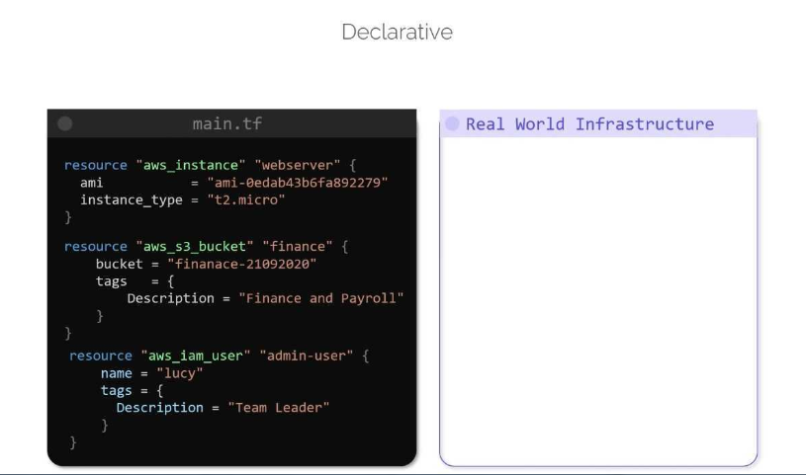

Main.tf is a desired state and on the right side it is our current state.

Init: Terraform initializes the project and identifies the providers to be used for target environments.

Plan: Terraform drafts the plan to get to the target phase.

Apply: Terraform makes the necessary changes on the target environments to bring it to the desired state.

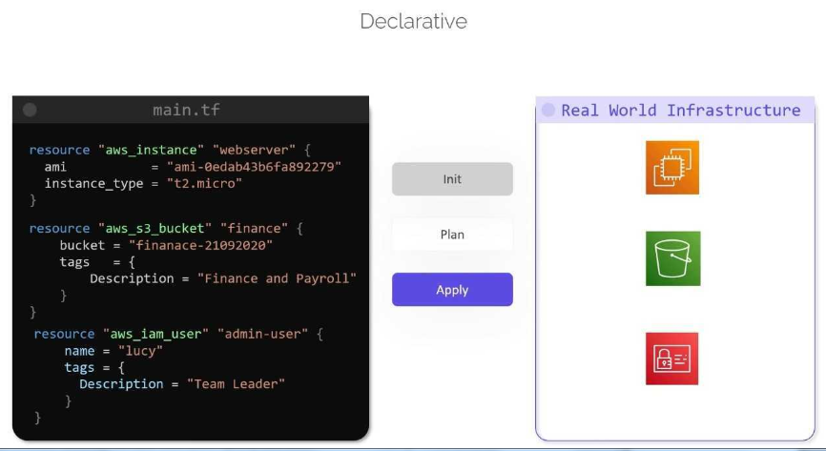

If for some reason, the **target environment shifts from the desired state**, then “terraform apply” will bring it back to the desired state by **only fixing the missing component**. i.e S3 bucket

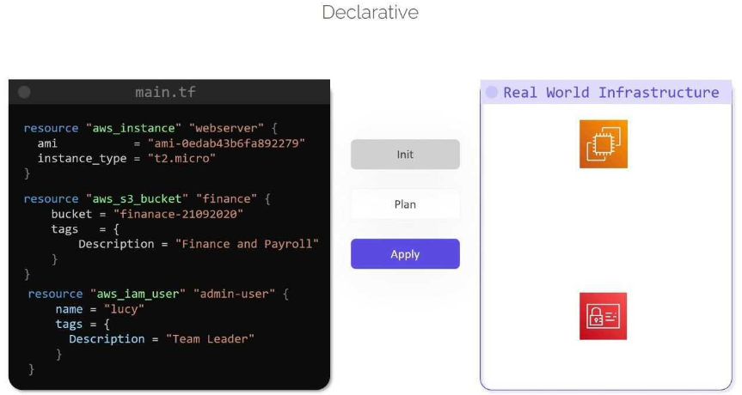



Terraform records the state of the Infrastructure as it is seen in the real world and based on this it determines what action to take by updating the resources for particular platform. **State file** is the **blueprint of infrastructure** deployed by terraform.

Terraform can **read attributes** of existing infrastructure by configuring the “**data sources**”. This can be used for **configuring other resources** in terraform.

It also imports other resources outside of terraform which are created manually or by using other IAC tools.

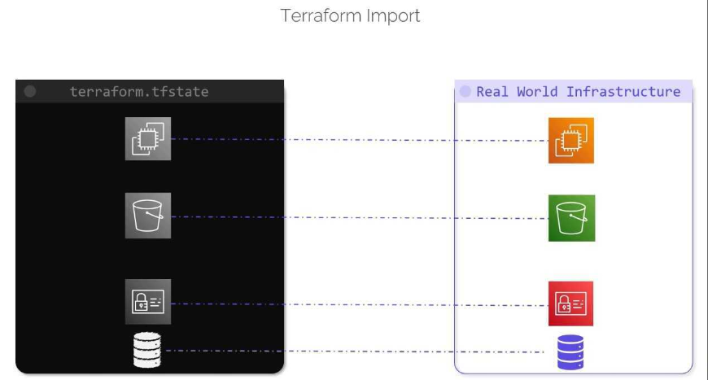

#Removed line content = "Hi Ajinkya Chandekar" and doing “terraform plan”

File: main.tf

=====================================================================================

resource "local_file" "ajinkya" {

filename = "/root/terraform/ajinkya.txt"

}

It will do ( -/+) means delete existing file and create a new file with “No Content”

This proves that terraform is used to create “IMMUTABLE” infrastructure.

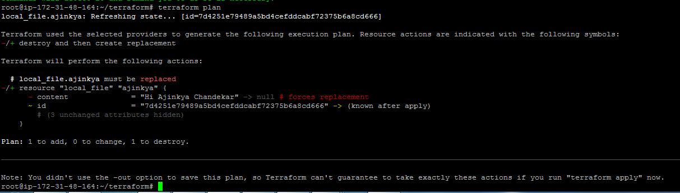

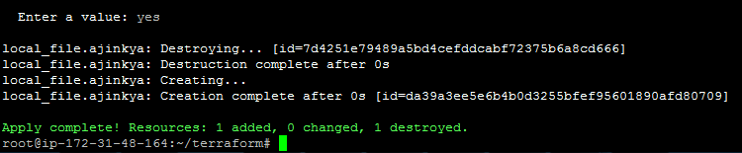

New terraform.tfstate file will be created. It will keep only two states as shown below.

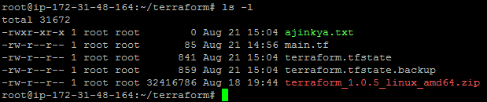

terraform.tfstate.backup

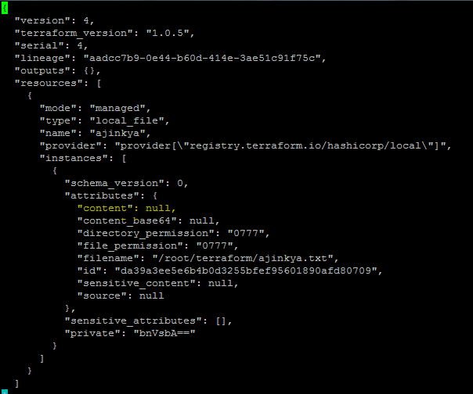

File: main.tf

=====================================================================================

resource "local_file" "ajinkya" {

filename = "/root/terraform/ajinkya.txt"

content = "Hi Milind Chandekar"

}

terraform.tfstate

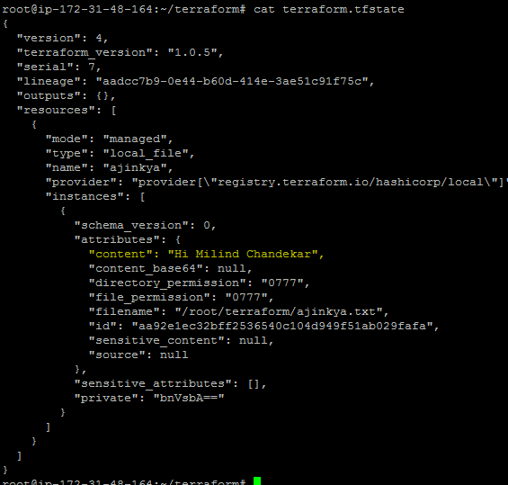

Run main.tf again (No changes in arguments)

